i-Ready
Where to find tips for Reliable Administration and Scoring

- Login to the iReady Webiste into i-Ready Central.
- As is illustrated below choose the “Diagnostic” from the right hand side.

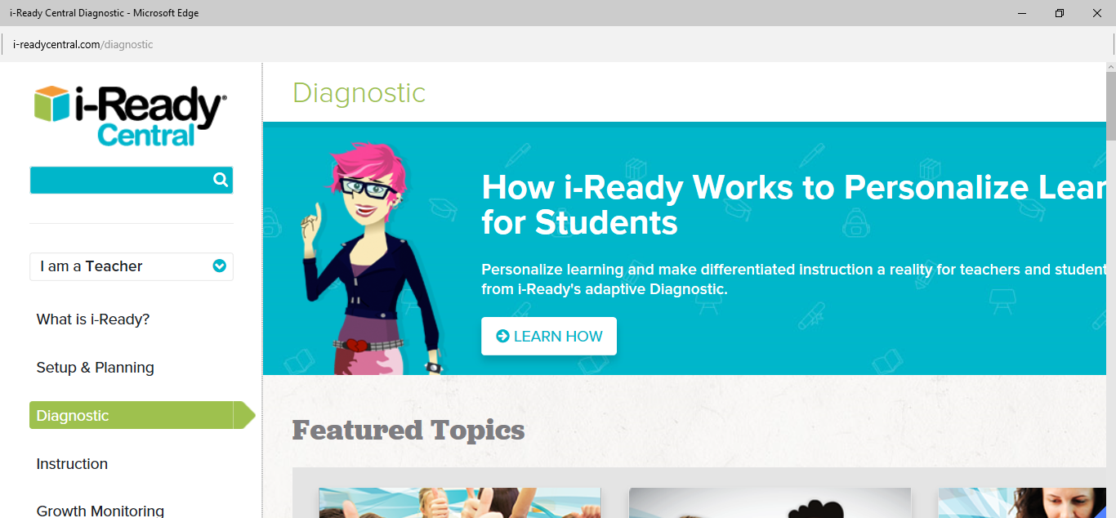

Scroll down the page to find the following heading…
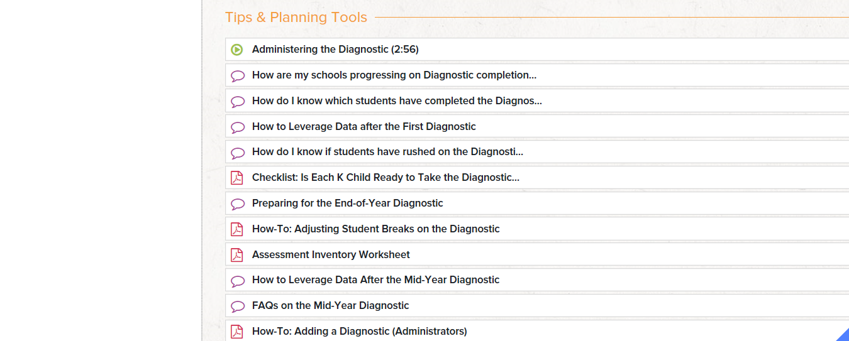
Under “Tips & Planning Tools” you will find a variety of videos, blogs, and documents on how to reliably administer the i-Ready Diagnostic test.

